ASTRA Tutorial – Create an Event

- Log into ASTRA via onelogin on NCTC home page. You will land on the Astra dashboard.
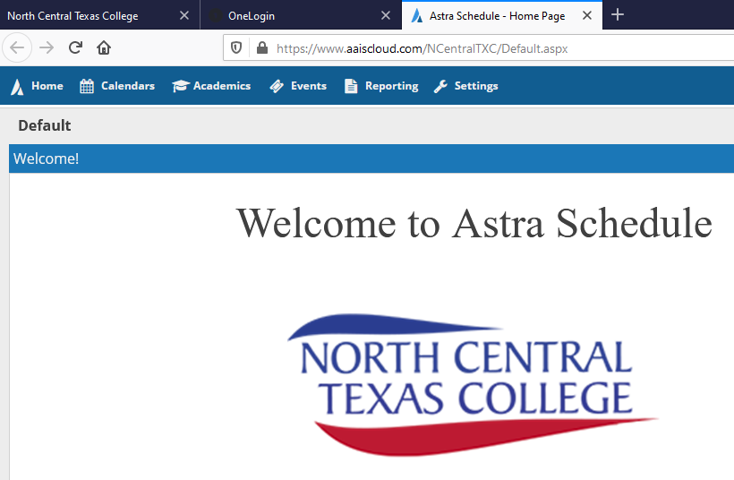

- To schedule a room, click on Request Events.
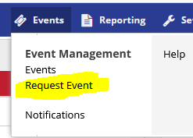

- The Event Request Wizard pop-up box will appear. Select the desired campus from the drop-down menu.
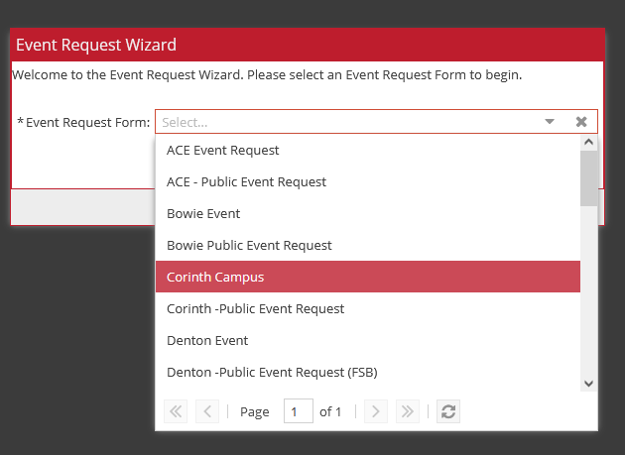

- Once campus is selected, you will land on the Event Information page where you will fill out required event information. Select “Add Meeting” once info has been entered.
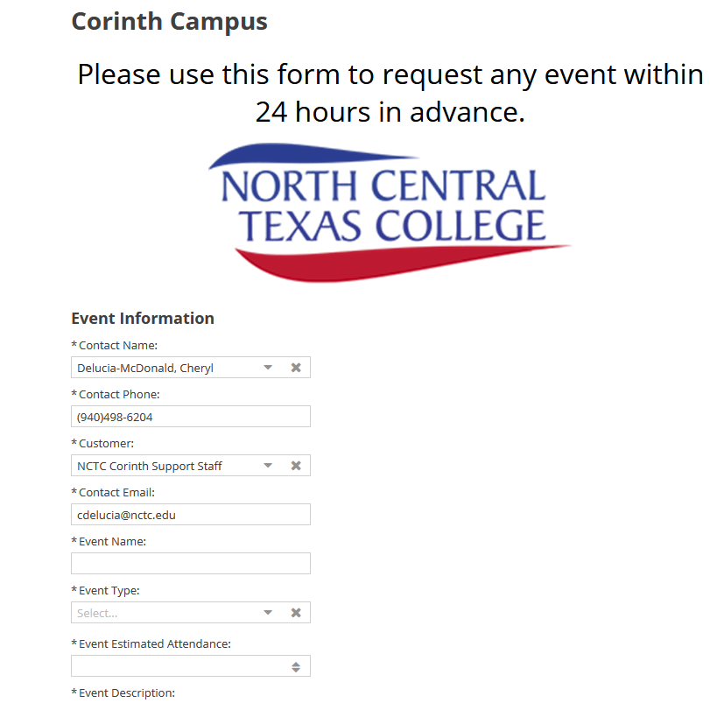
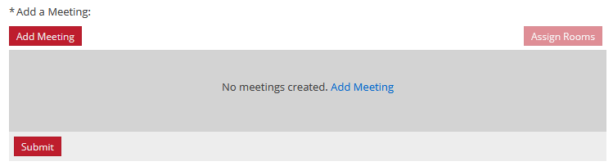

4. After selecting “Add Meeting”, the “Create Meeting(s)” box will appear. Enter information required and click “Add Meeting”.
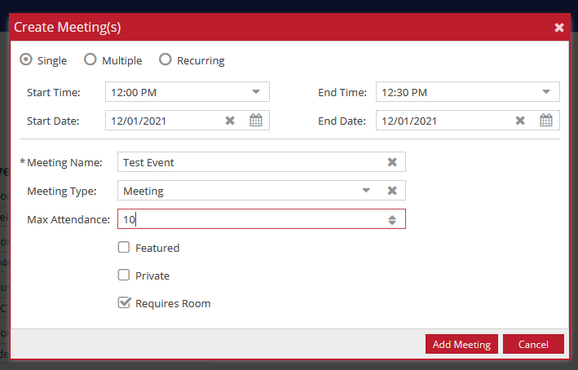
- After adding meeting, you are redirected back to the Event Information page where you will then assign a room. Click the “Assign Rooms” button.
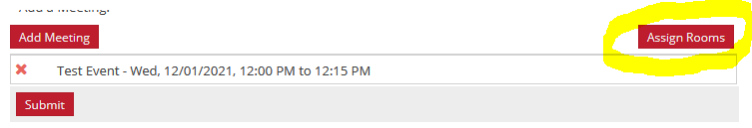
- The “Assign Room” box will appear where you will select Campus and any other features desired in the left hand side of the box. Select desired available room on the right hand side of box. Click “ok”
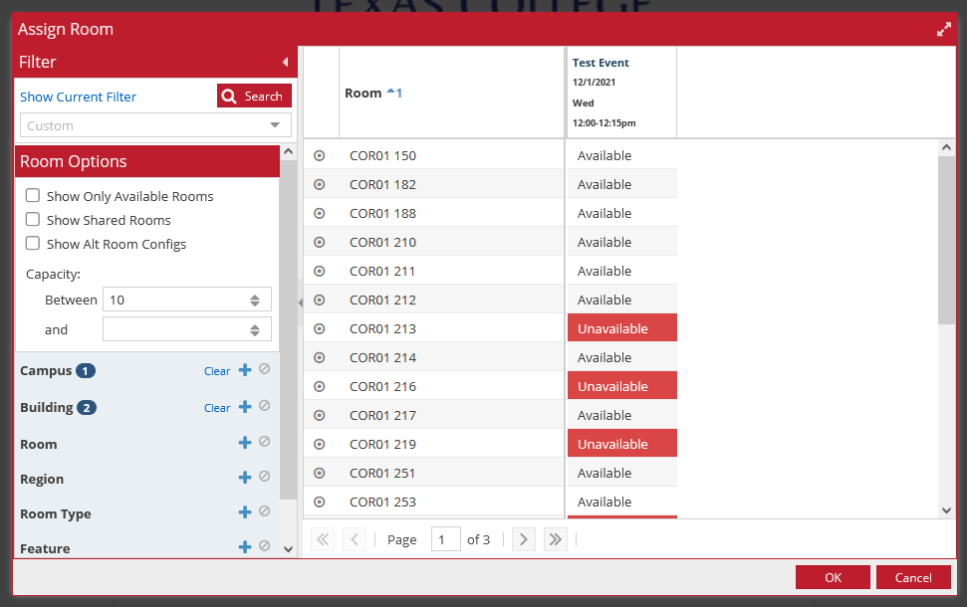
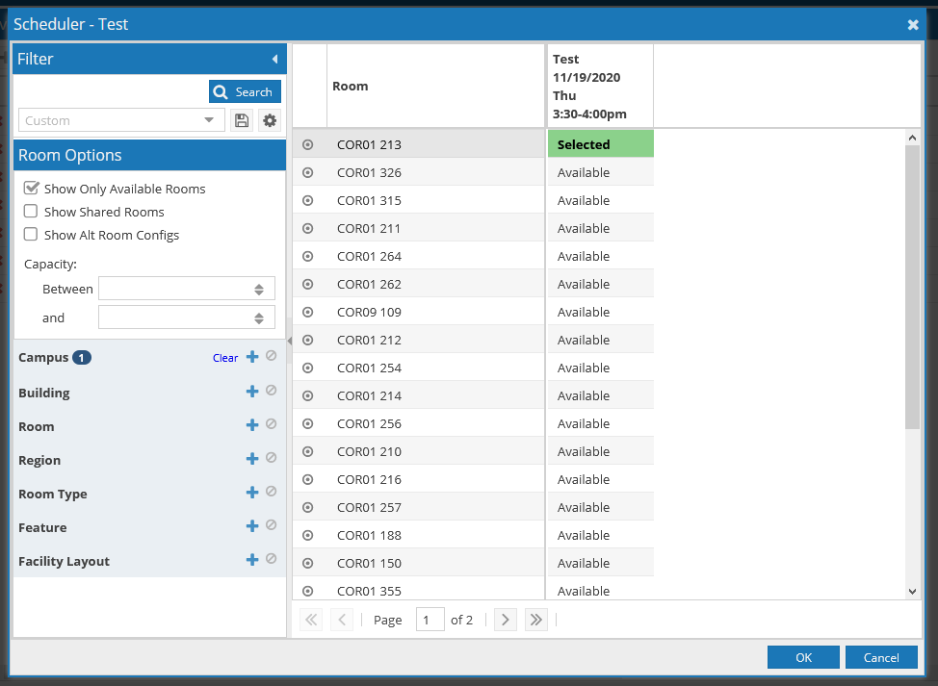

- You will once again be redirected back to the Event Information page where you will now select the “submit” button to submit your room request. After submitting, you will receive an email of your event information. An approver on each campus will review the request and either approve or change the room and you will receive another confirmation email.

