Setting Up NCTC Auto-Signature

These instructions are for setting up your NCTC signature so that it follows the *NCTC Email Signature Guidelines*. This will walk you through creating and setting the signature to be added automatically to your new emails, replies, and forwarding. Step 7 has the example you will need to follow, be sure to not change anything with the formatting. If you have any questions, please reach out to the IT department.

1. Create a new email

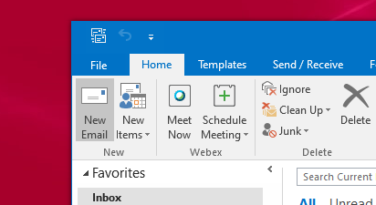

2. Click on “Signature”   
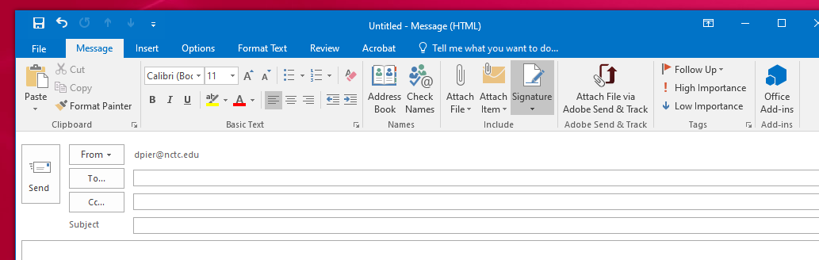

3. Choose “Signatures…”  
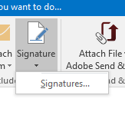

4. This is the box that should come up. This is where you will create your signature.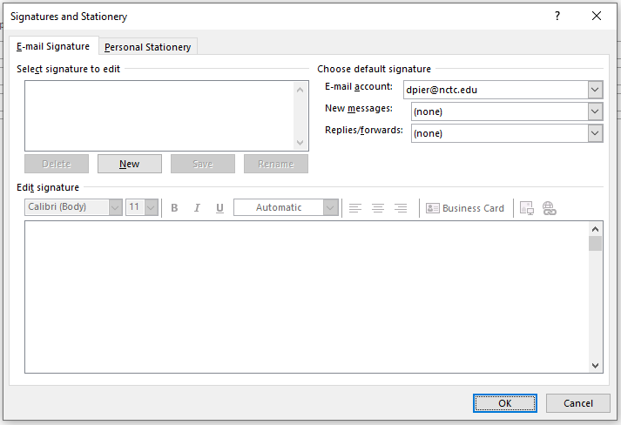

5. To create a signature, click on “New”   
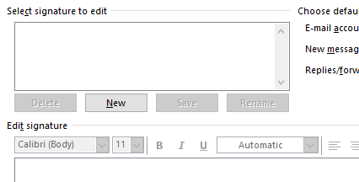

6. Name the signature, this guide names it “NCTC”  
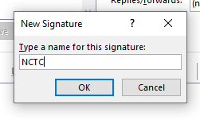

7. Take the following example and edit it to include your information. You can copy and paste this into the Edit Signature box to edit it.

**Full Name**

Title

Department/Office

Physical Address

City, State, Zip

(area code)555-5555

Email address

[nctc.edu](https://linkprotect.cudasvc.com/url?a=http%3a%2f%2fwww.nctc.edu%2f&c=E,1,9f9B7m7ZEZXfah-pyOK1We-i0FbUnDedle4cSlhZwwVwAobJTqLvUZi0-GPo0Bda5jkdfDXBpcu80Y5occgupuQ6Brf3lY1KsP1tb6CgKhHV8A,,&typo=1)



***NOTE: You can copy the logo above and paste it along with the rest of the example into the “Edit Signature” box.***

8. Edit the example with your information.   
  
Keep in mind that it must follow the *NCTC Email Signature Guidelines*. Font cannot be changed- the **color remains black** and the **size remains pt. 10**. The name is the only part that is bold. The link and email are the only parts that will be blue.

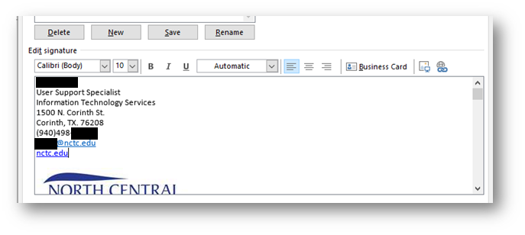

9. Now, save your changes to the signature by hitting “Save”  
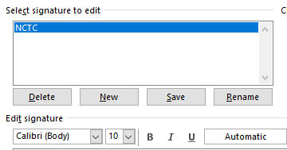

10. Lastly, you will want to set it to use this signature by default. The top right section “Choose Default signature”, using the drop down arrows, select your newly created signature.

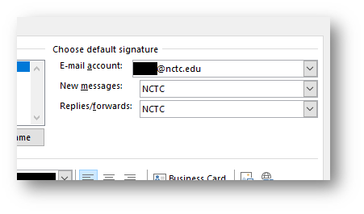

Once all of these steps are complete, hit the “OK” in the bottom right-hand corner.

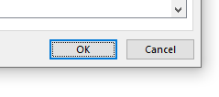

If setup correctly, if you open a new email or reply, the signature will be added automatically.